Big Data – Case Study

Sentiment Analysis on tweets regarding demonetization in India

Framework: Hadoop – HDFS, PIG, HIVE Programming Language: Python

Step 1: Opened the terminal application on the Cloudera VM desktop

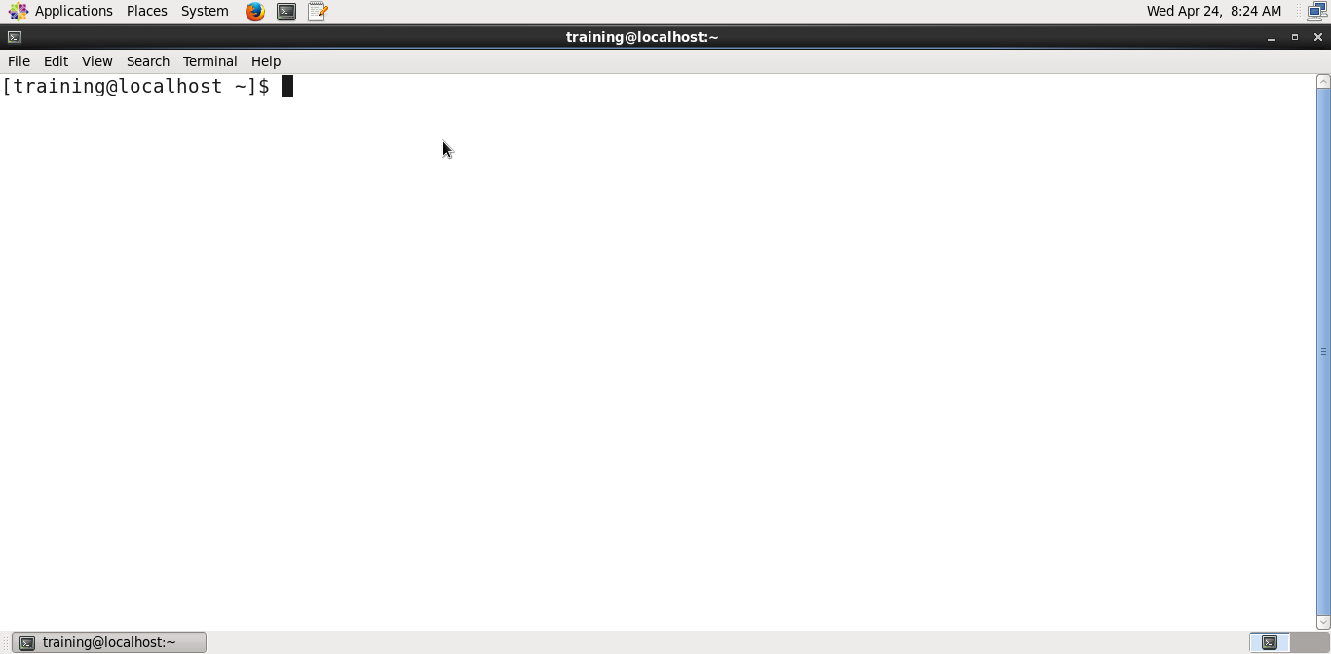

Step 2: Downloaded the required file to analyze tweets

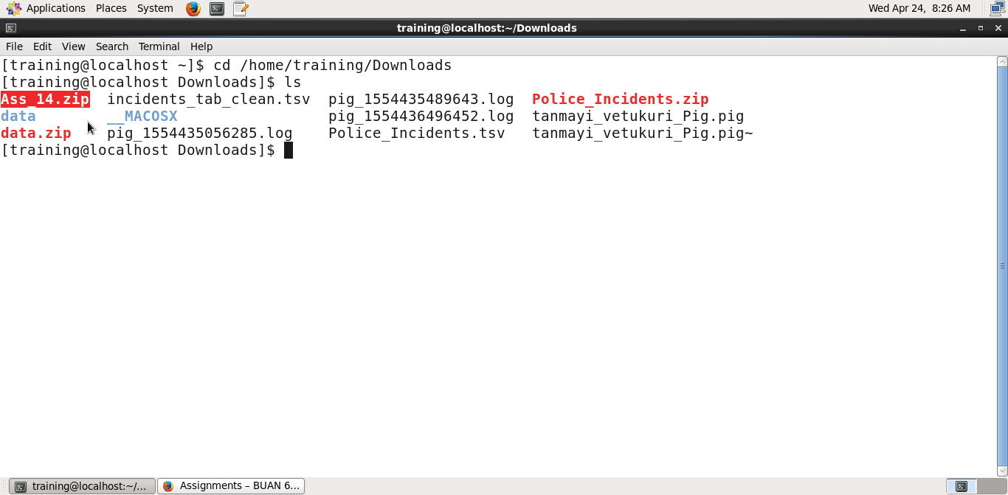

Step 3:

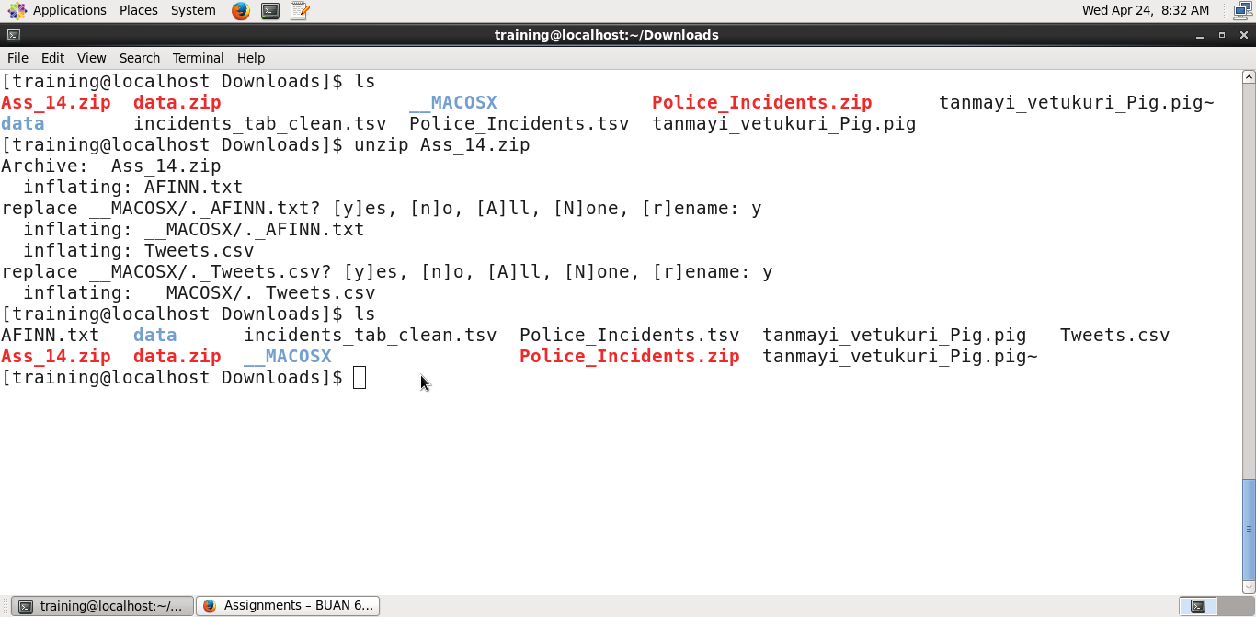



Step 4: Created directory to be used for case study and moved files with tweets into this directory

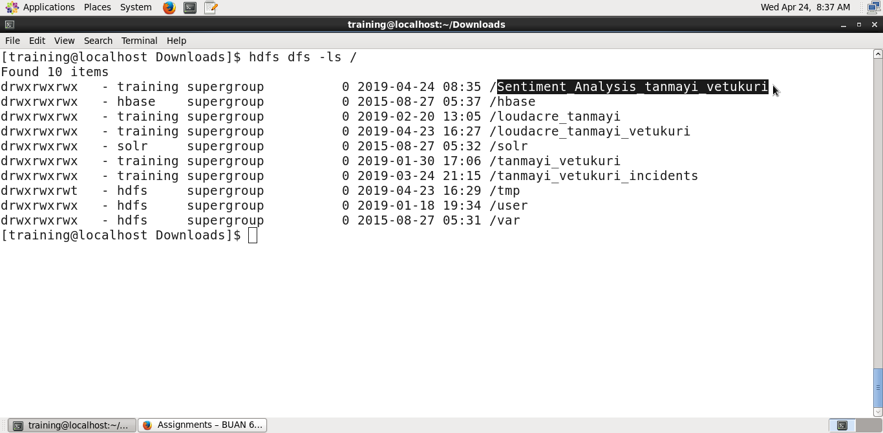

Step 5:

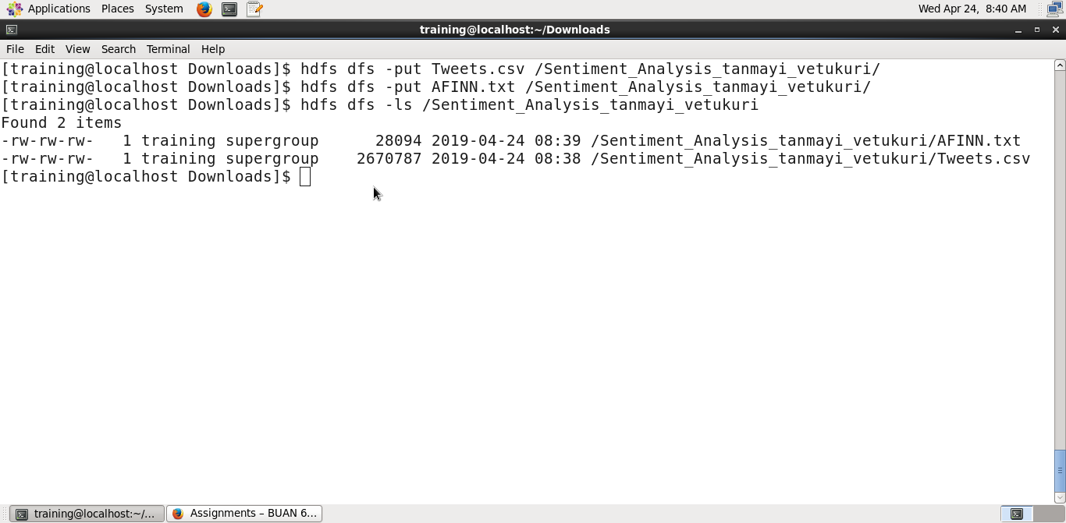



Step 6: Executed PIG command to open grunt shell

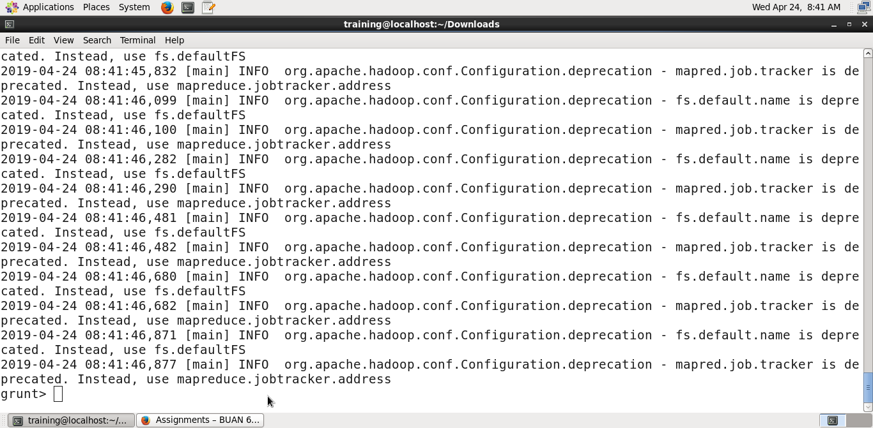

Step 7: Loaded Tweets.csv file to Demonit_Tweets and displaying data in Demonit_Tweets

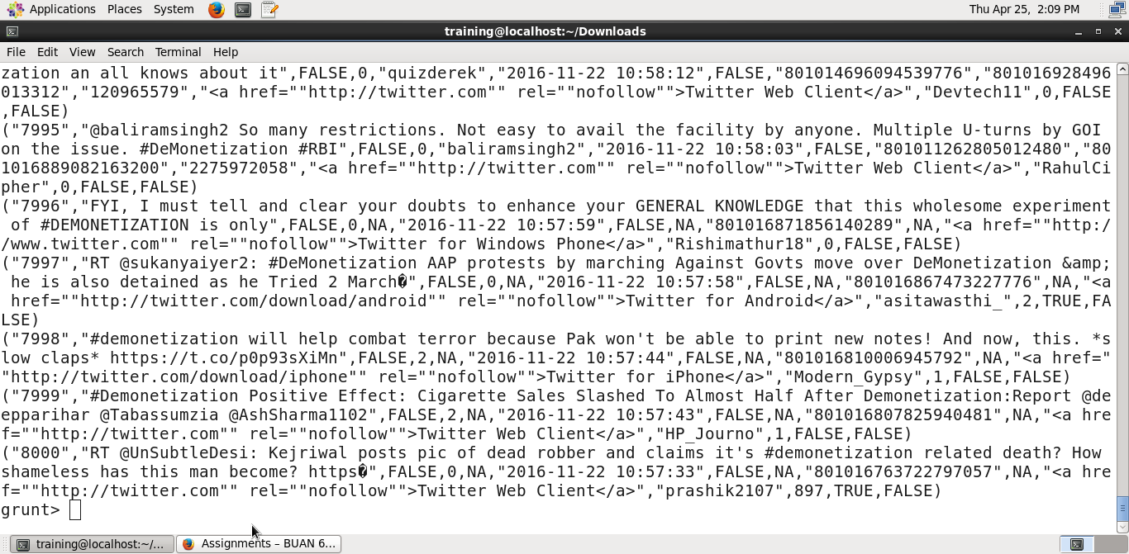

Step 8: Defining and collecting the first two data elements in the csv file and dumping the data at the grunt shell. Command used -> data_extract = FOREACH Demonit_Tweets GENERATE $0 as id, $1 as text;

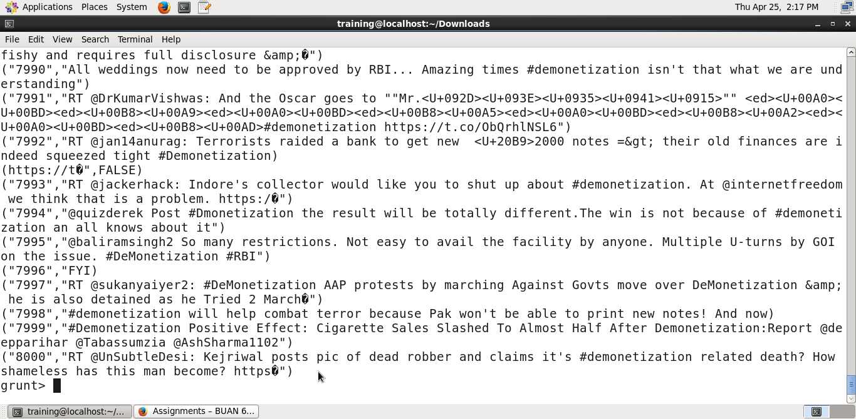

Step 9: Defining a third element by breaking down the text information in the variable ‘text’ into words

Code -> data_tokens = FOREACH data_extract generate id, text, FLATTEN(TOKENIZE(text)) as words;

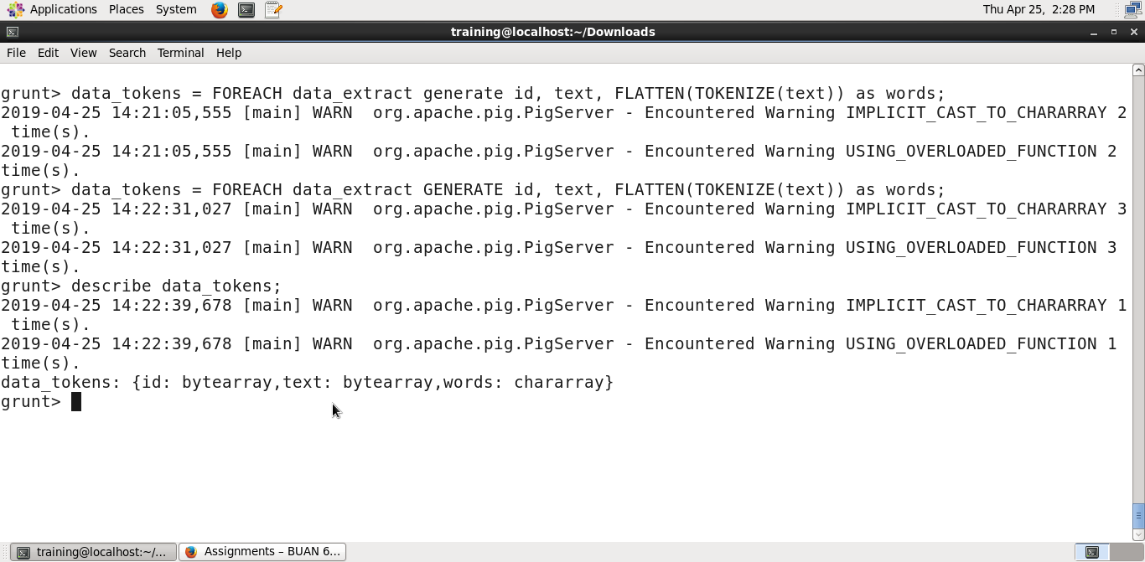

Step 10: AFINN dictionary is a dictionary consisting of 2500 words that are rated on a scale from -5 to +5 depending on the sentiment the word conveys. Used this dictionary to perform the sentiment analysis on tweet data.

Code -> word_dict = LOAD ‘/Sentiment_Analysis_tanmayi_vetukuri/AFFIN.txt’ USING PigStorage(‘\t’) AS(word:chararray, rating:int);

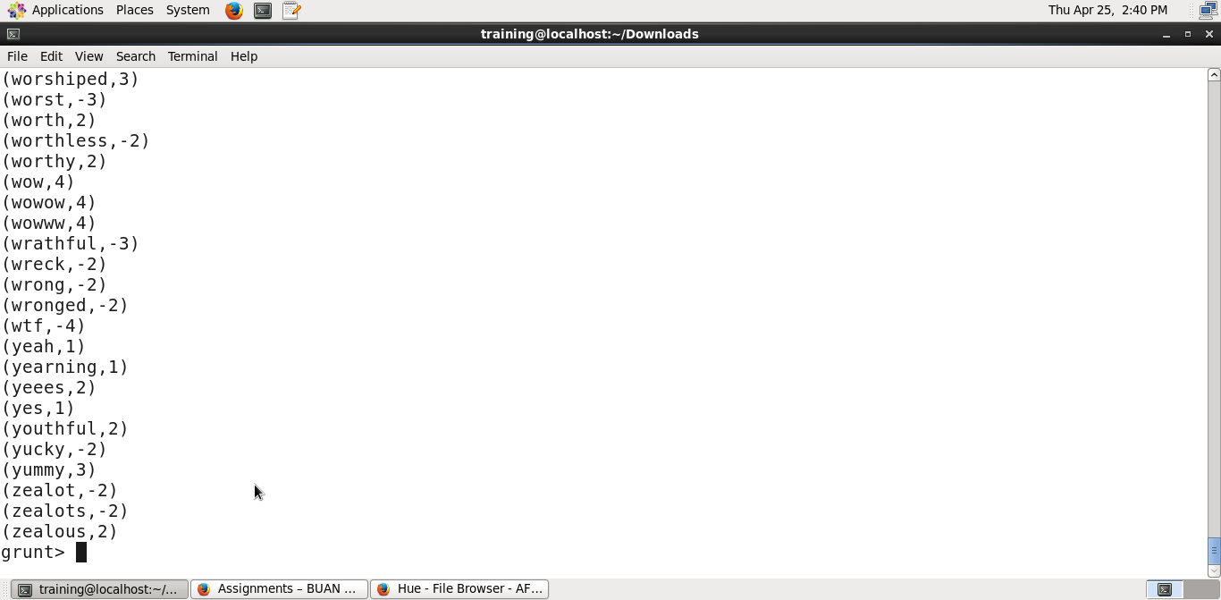

Step 11: Joined sentiments values from the AFINN dictionary with the words in the text from each tweet.

Code -> sent_join = join data_tokens by words left outer, word_dict by word using ‘replicated’;

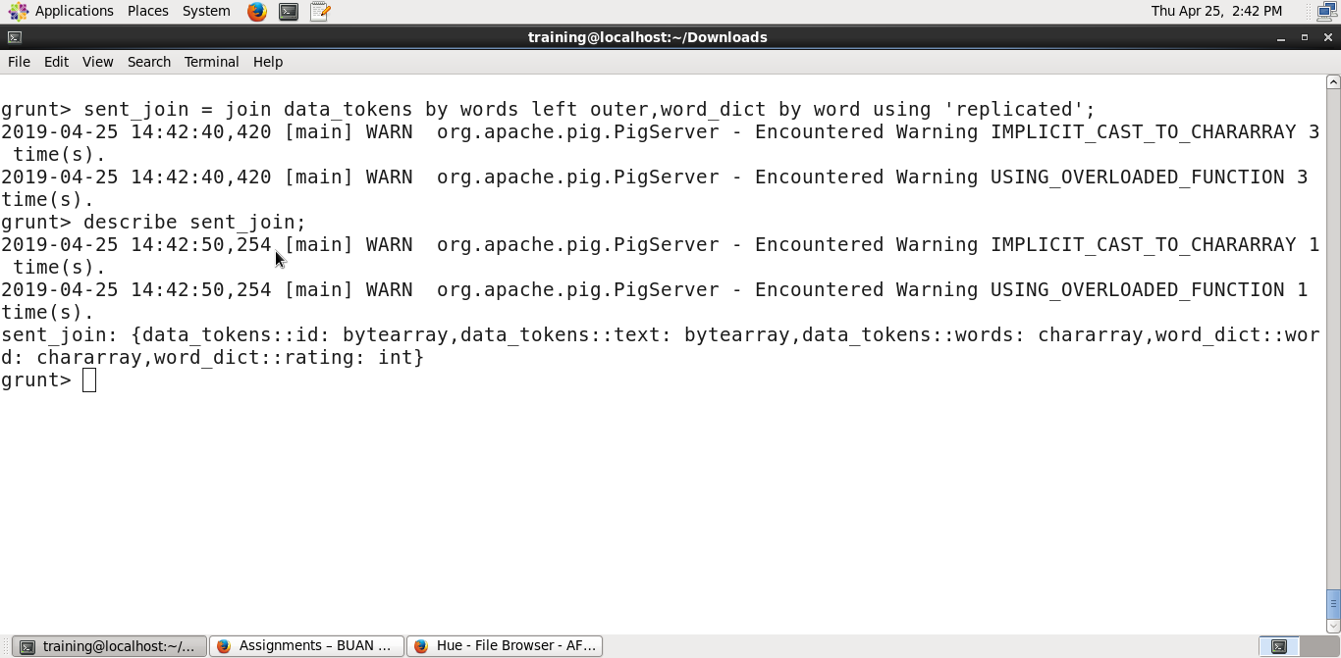

Step 12: Extracted data from the variable in step 12 i.e. sent_join that is needed to complete sentiment analysis.

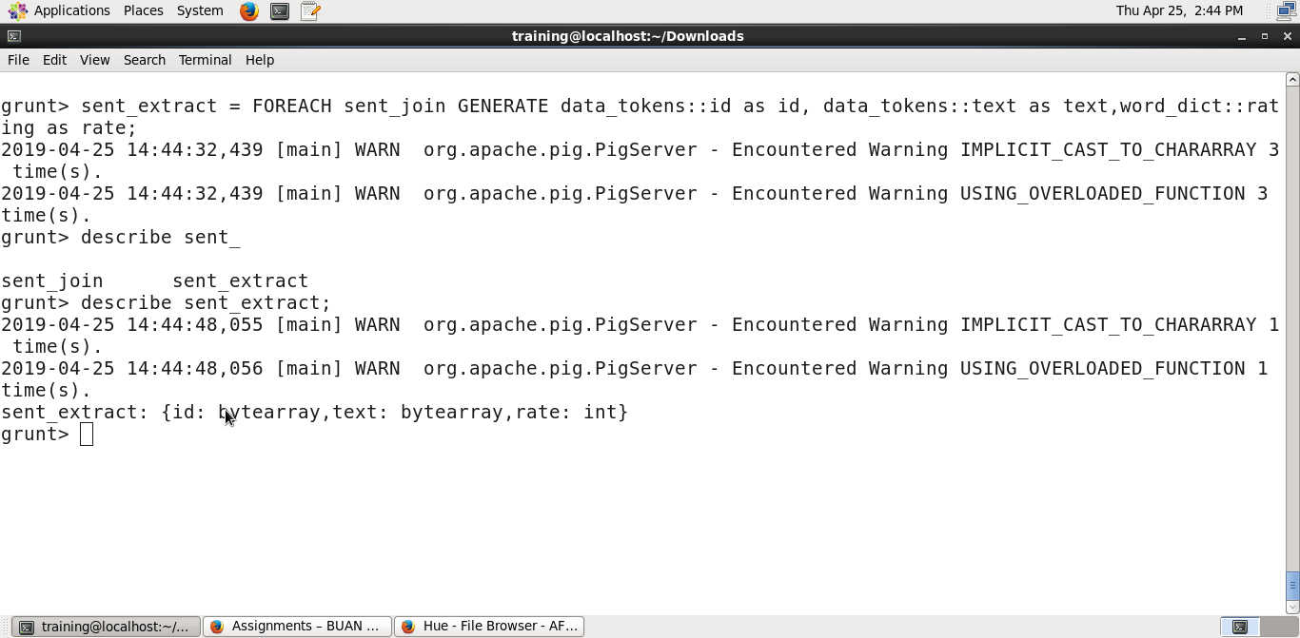

Step 13: Grouped each record by its id and text

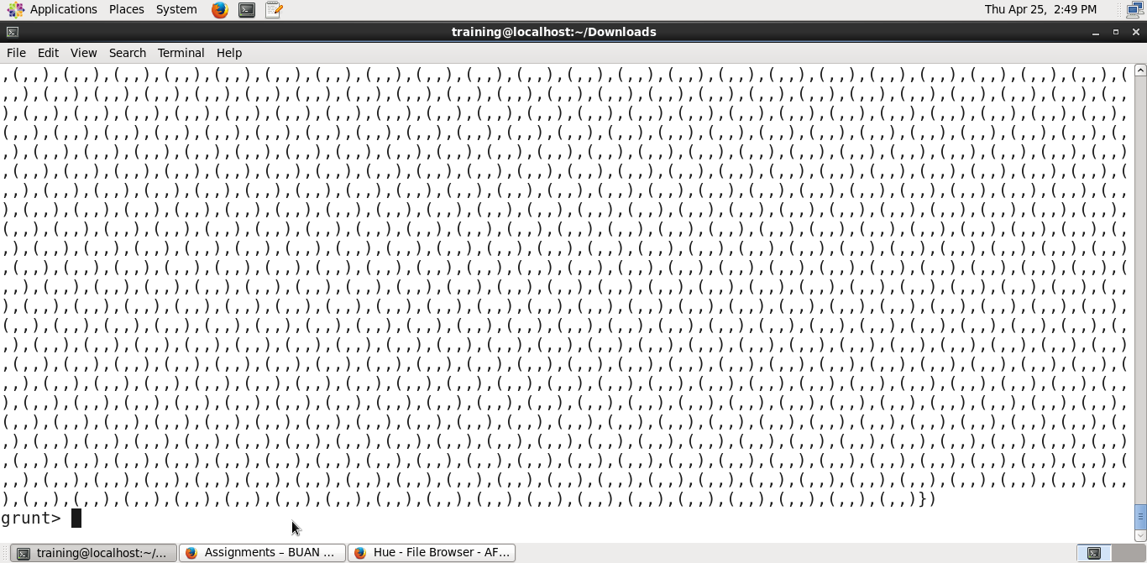

Step 14: Averaging the rating for all the words in each tweet and storing the result in average_rating.

Code -> average_rating = FOREACH word_grouping generate group, AVG(sent_extract.rate) as tweet_rate

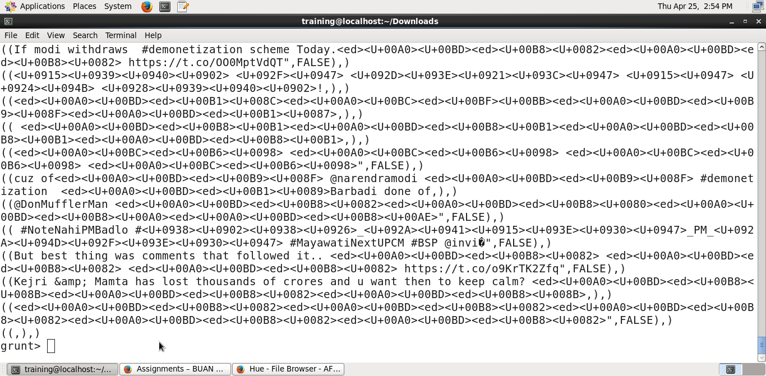

Step 15: Filtered all the tweets for those tweets that have an average rating >= -5.

Code -> final_tweets = filter average_rating by tweet_rate >= -5;

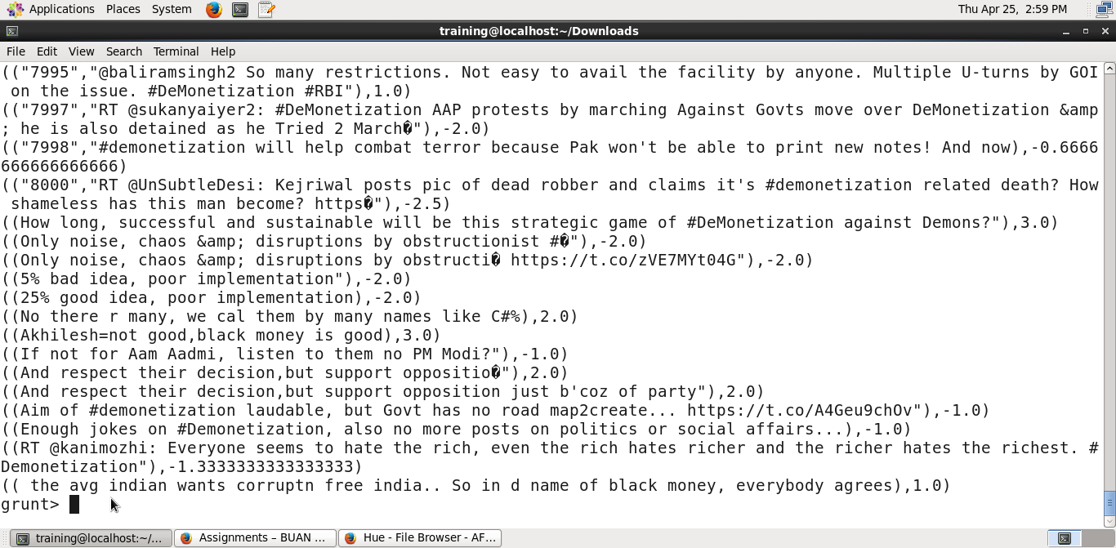

Step 16: Stored final_tweets into Sentiment_Analysis_tanmayi_vetukuri/Analyzed_Tweets

Code -> STORE final_tweets INTO ‘/Sentiment_Analysis_tanmayi_vetukuri/Analyzed_Tweets’;

Viewing the output of the Analyzed_Tweets file in HUE.

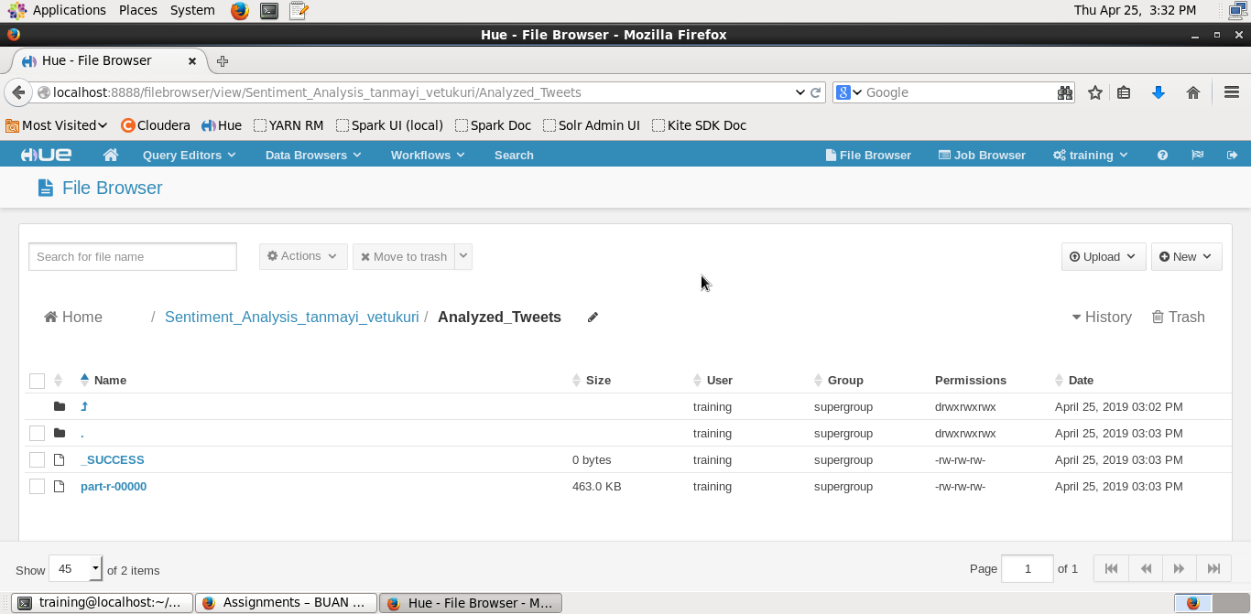

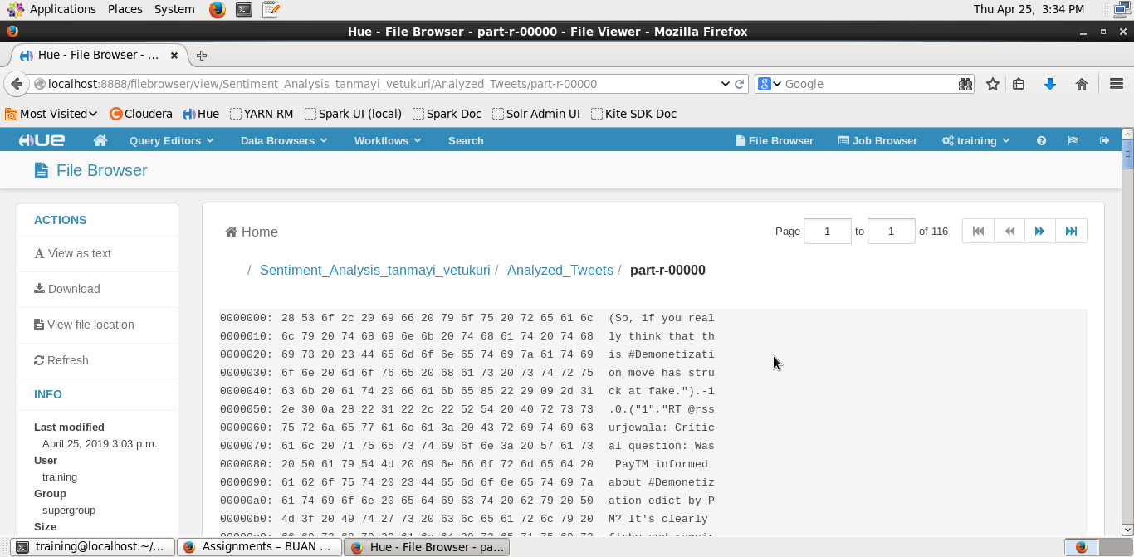

Step 17: Started beeline to execute the hive commands

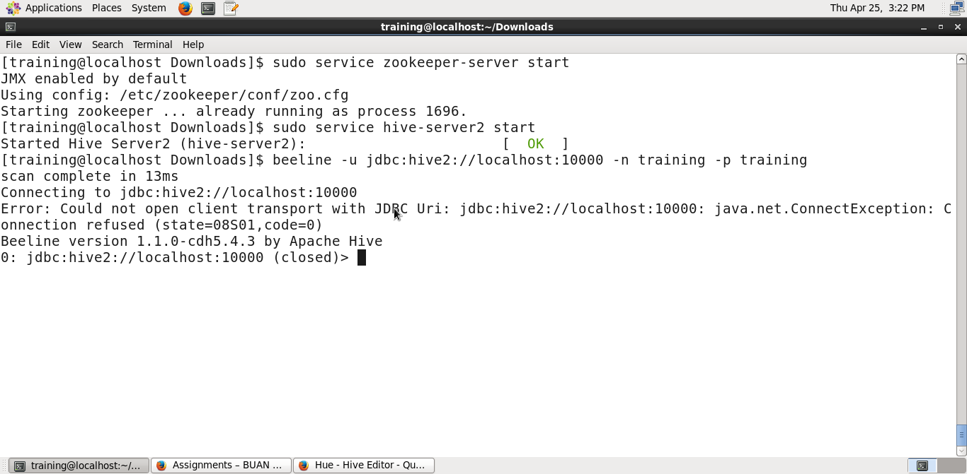

Step 18: Created a hive table to structure the unstructured data

Query -> CREATE EXTERNAL TABLE tweety (text STRING, tweet_rating DOUBLE) ROW FORMAT DELIMITED FIELDS TERMINATED BY ‘)’ LOCATION ‘/Sentiment_Analysis_tanmayi_vetukuri/Analyzed_Tweets’;

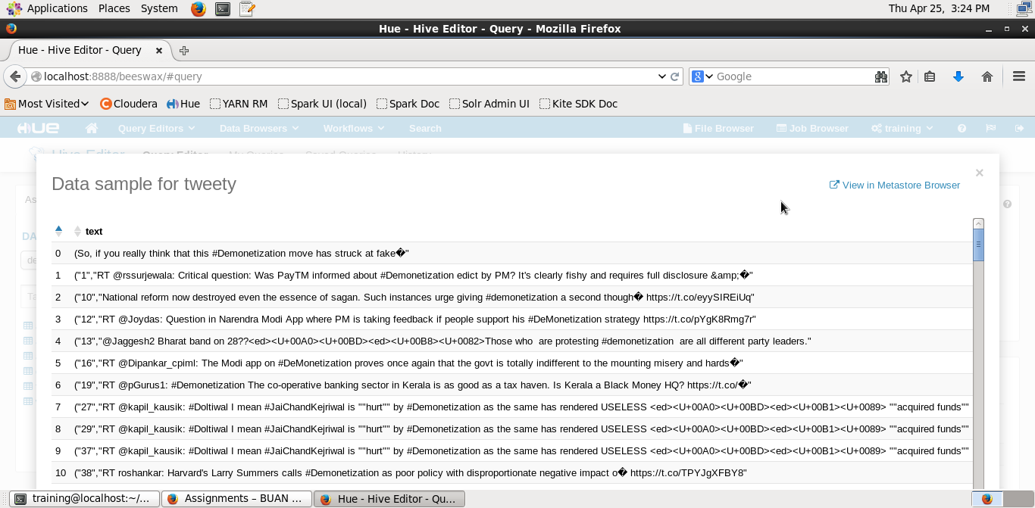

Step 19: Created a .csv file from the table created in Step-20

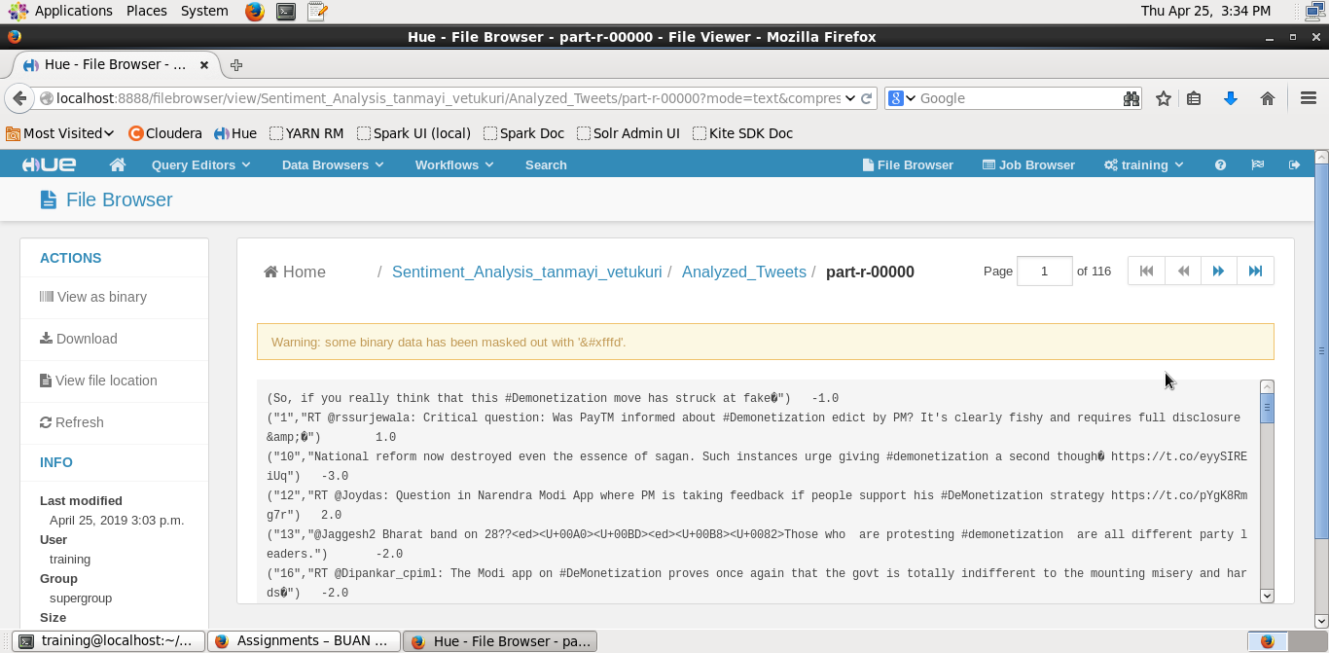

Step 20:

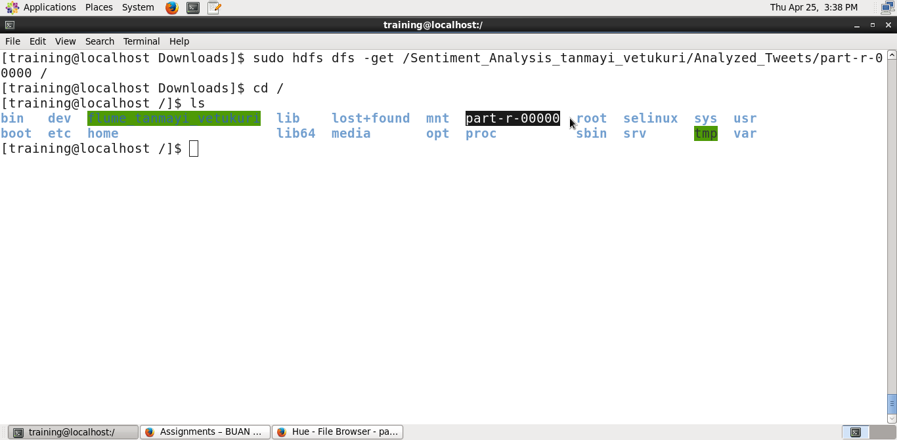

Step 21: Created a graph using Python to understand the impact of sentiment score.

Code ->

import matplotlib.pyplot as plt

import pandas as pd

sentiment = pd.read_csv(‘part-r-00000’, demiliter = ‘\t’)

tweet = sentiment[‘-1,0’]

plt.hist(tweet, edgecolor=’black’, linewidth = 1.2)

plt.xlabel(‘Sentiment Value’)

plt.ylabel(‘Count’)

plt.show()

Step 22:

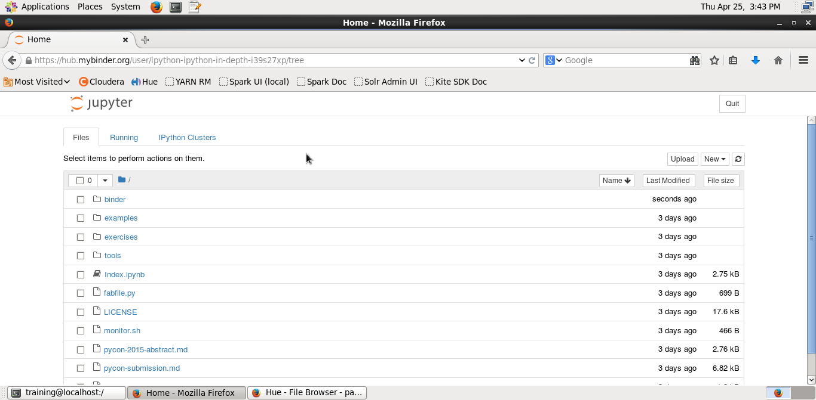

Step 23:

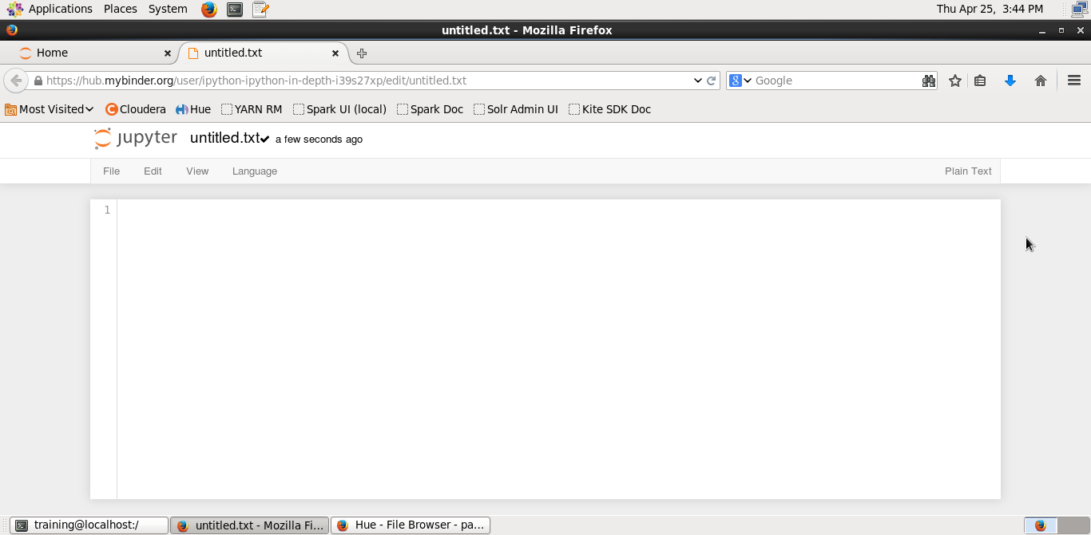

Step 24:

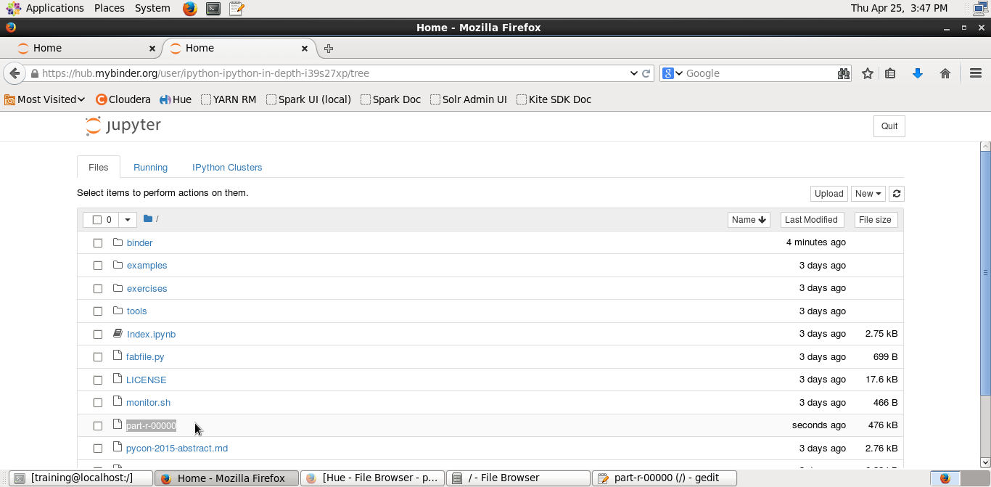

Step 25:

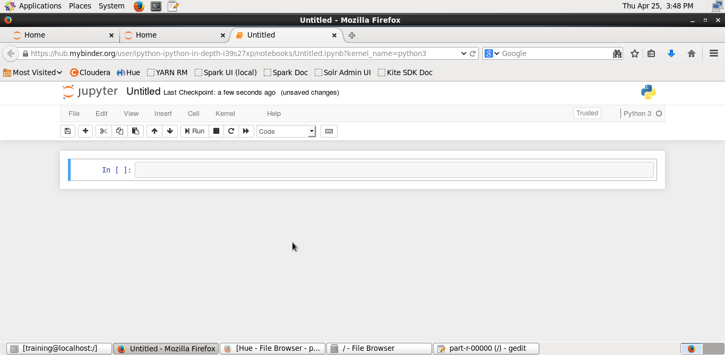

Step 26: From the graph we can say that there are more values for positive sentiment value

